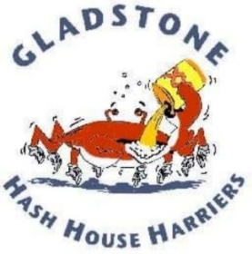
Gladstone Hash House Harriers
Rego Form 2222 RUN 28TH-30th June 2024
Where : CAMP AKUNA Pike Crossing Rd Banaraby( Lake Awoonga Rd turnoff)
REGO $90 by 1 June 24☆ $100 after ☆$80 Non Drinker
Hash Name............................................Real Name.............................................
Hash CLUB.............................................
Phone.............................Email................................................
Grog Preference: Beer: Mid □ Heavy □ Zero □
Wine: White □ Red □
Food Allergies...................................................
Shirt Size................................Friday Early Arrival..................
Payments to Gladstone Hash House Harriers BSB 734-126 Acc 071-093
Send payment Remit/Rego to email gladstonehashouseharriers@gmail.com
Other useless information
Sign on 12 noon Run 1.30pm
Includes SAT Lunch Dinner Sun Beaky Run Thrilling Entertainment Draw into POT of Gold
Friday Early arrivals : Camp Site Covered. Pay for Beer /Wine $3 or BYO. Nosh Available for Fri Dinner SAT Breaky $10 pp
Accommodation : Tent Swag Caravan or Doss in Dormitory (no mattresses)
Other Accommodation available at Lake Awoonga CAMP or Awoogna Gateway Lodge (6km from Venue)
Theme : Best Dressed Tutu on run otherwise you’ll look like an idiot?
NO sprogs brats or dogs! 18+
Contact Bit Rusty: 0473653095 Ding Dong : 04076506168 Seimens:0437628338

