**KENNELCOCK**

**Founding Father of Cutlery H3**

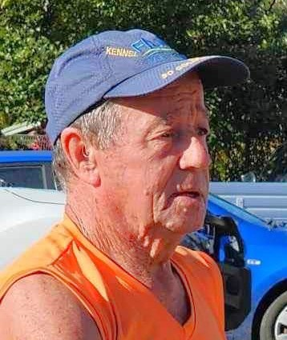

WILL BE CELEBRATING

**1000 RUNS**

ON SATURDAY, 24 MAY 2025

CUTLERY HASH is organising a special event at the

***Yeppoon Bowls Club at 3pm***

There will be a short run/walk, followed by a Circle and celebration

A complementary drink will be provided

The meal and other drinks will be at your expense

Please advise MD on 0429336877 or [muffncock2@bigpond.com](mailto:muffncock2@bigpond.com) by 7 May

if you will be attending