TOWNSVILLE TVH3 CELEBRATION RUN 2600
19-21 JUNE 2026
THEME – ‘’MAGICAL MUSICAL MAYHEM’’
VENUE – CRYSTAL CREEK CARAVAN PARK
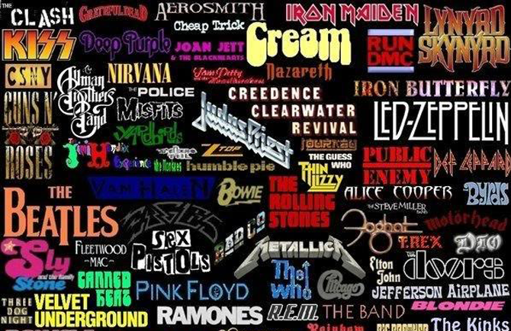
COST - $140 – HASHERS ARE RESPONSIBLE FOR THEIR OWN ACCOMODATION BOOKING AND COSTS

Registration includes; Friday night dinner, Saturday lunch, dinner and breakfast Sunday.
Music Trivia Night ‘with a twist’ Saturday night
Prizes for the winning team, Best Dressed Male and Female, Lucky Door and more!!
BYO DRINKS FRIDAY NIGHT AND BREAKFAST SATURDAY
Payment by Direct Deposit or to the Hash Cash on a Monday night.
Bank Details – Townsville Hash House Harriers
BSB 633 000 Account 1572 43379
Reference – “your Hash name and Club’’
After payment, email Serenity at pmarhin@bigpond.net.au with payment confirmation AND include your Hash Name, CLUB and phone number.


