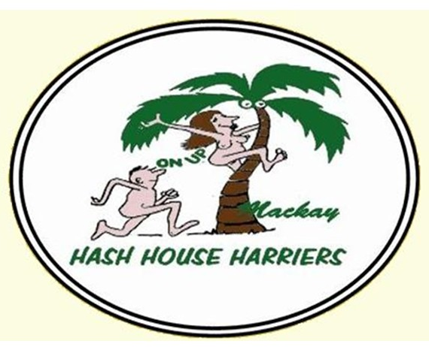

Date Claimer
Mackay Hash House Harriers
2400th Celebration Run

King’s Birthday Long Weekend
2-4 October 2026

More Information to follow

